Name: Neil Shah

PC – PC connection

Step 1: Connect 2 pc with cross wire.

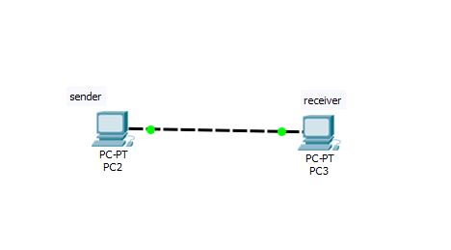

Step 2: Set the IP address

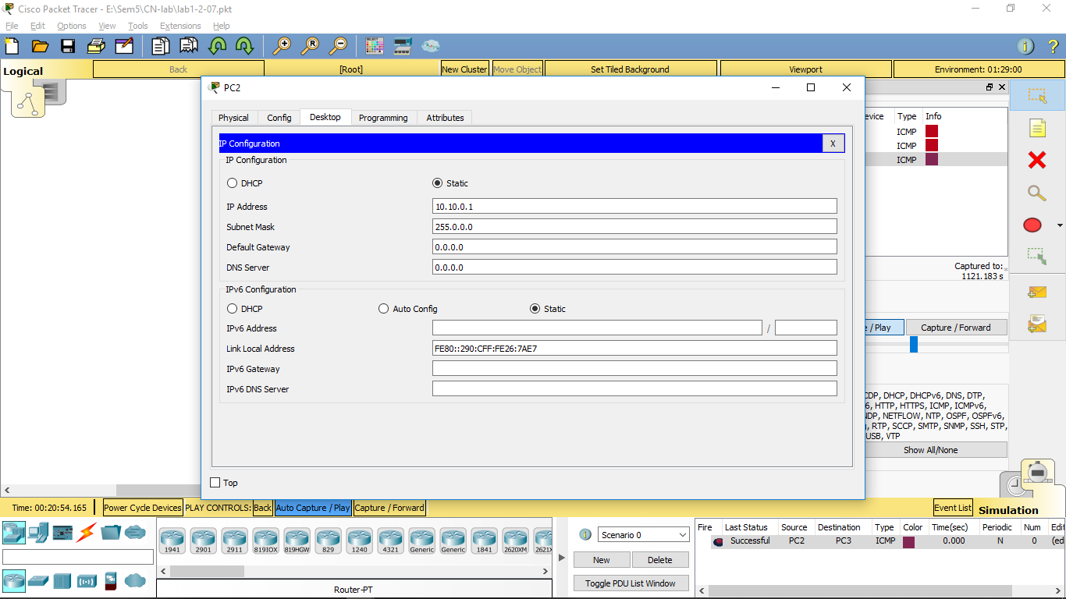

Step 3: Send the message and check

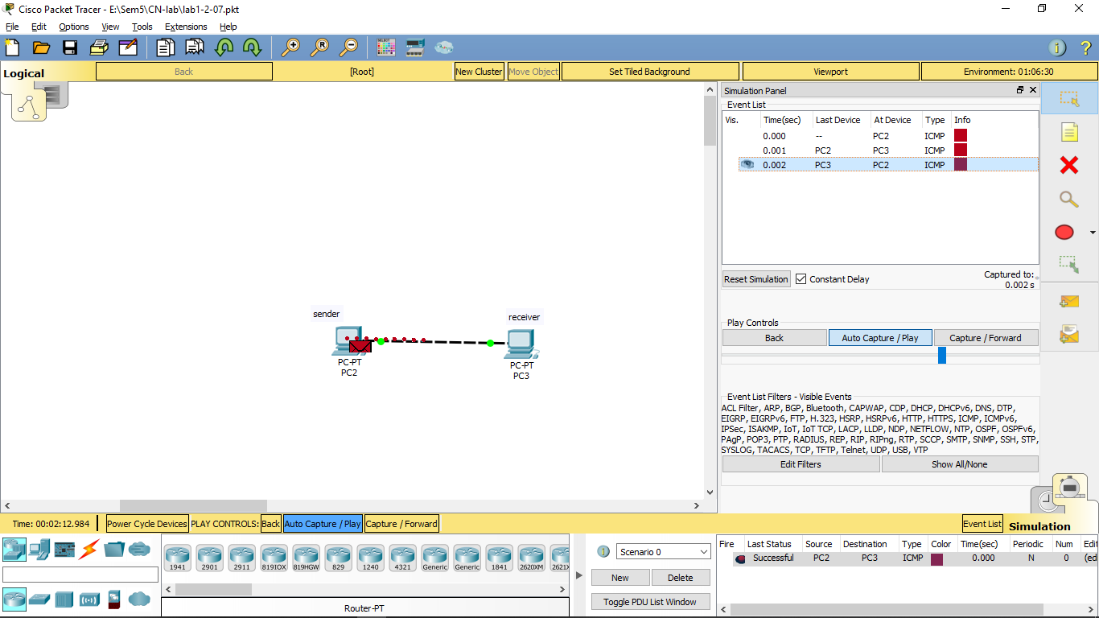

STAR TOPOLOGY

Alternatively referred to as a **star network**, **star topology** is one of the most common network setups. In this configuration, every [node](https://www.computerhope.com/jargon/n/node.htm) connects to a central network device, like a [hub](https://www.computerhope.com/jargon/h/hub.htm), [switch](https://www.computerhope.com/jargon/s/switch.htm), or computer. The central network device acts as a [server](https://www.computerhope.com/jargon/s/server.htm) and the peripheral devices act as [clients](https://www.computerhope.com/jargon/c/client.htm). Depending on the type of [network card](https://www.computerhope.com/jargon/n/nic.htm) used in each computer of the star topology, a [coaxial cable](https://www.computerhope.com/jargon/c/coaxialc.htm) or a [RJ-45](https://www.computerhope.com/jargon/r/rj45.htm) network cable is used to connect computers together.

**Step 1: Take PC and 1 Switch from bottom and put it on Logical wall**

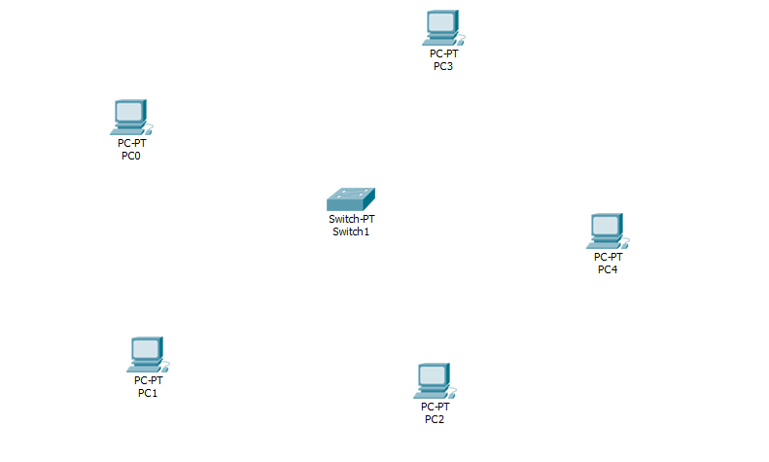

**Step 2: Connect with cross-wire from pc to switch.**

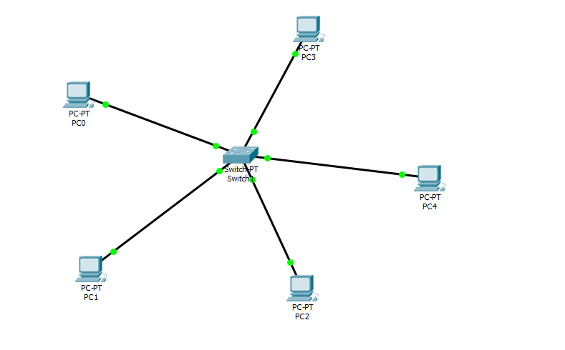

**Step 3: Assign IP address to all the PC**

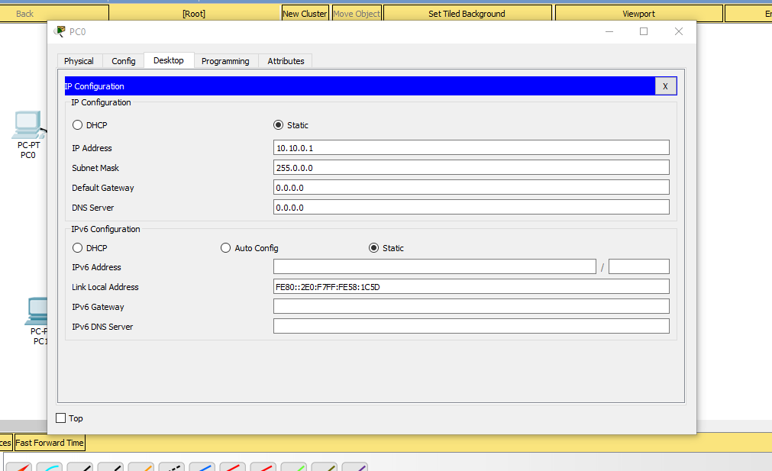

**Step 4: Send Message to pc 0 and pc 1 and check .**

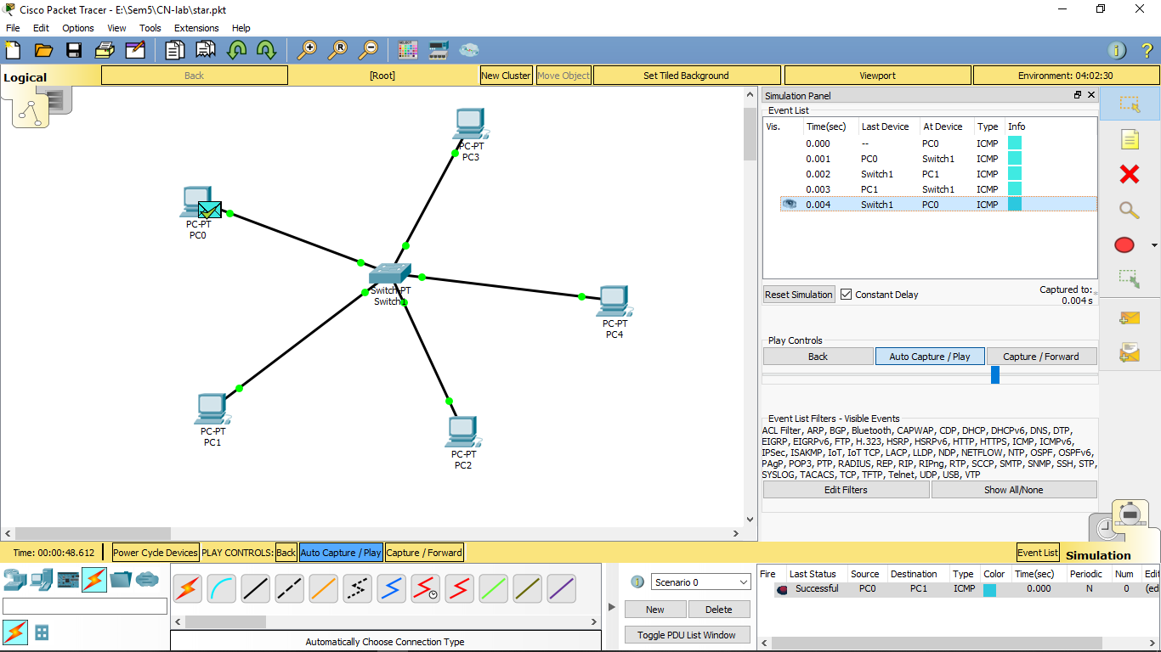

MESH TOPOLOGY

A network setup where each computer and network device is interconnected with one another, allowing for most transmissions to be distributed, even if one of the connections go down. It is a topology commonly used for [wireless networks](https://www.computerhope.com/jargon/w/wifi.htm). Below is a visual example of a simple computer setup on a network using a **mesh topology**.

1. Take 4 generic pc.

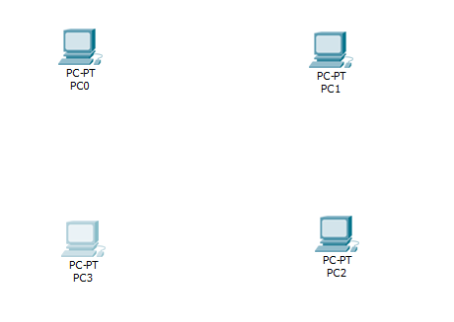

1. Take 4 Switches from the bottom and place it near pc on the logical wall

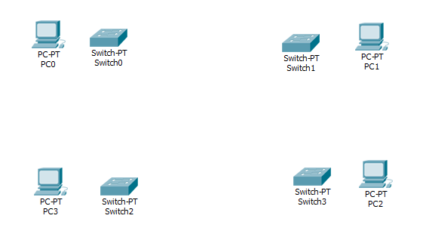

1. Set the Ip address to all the PC

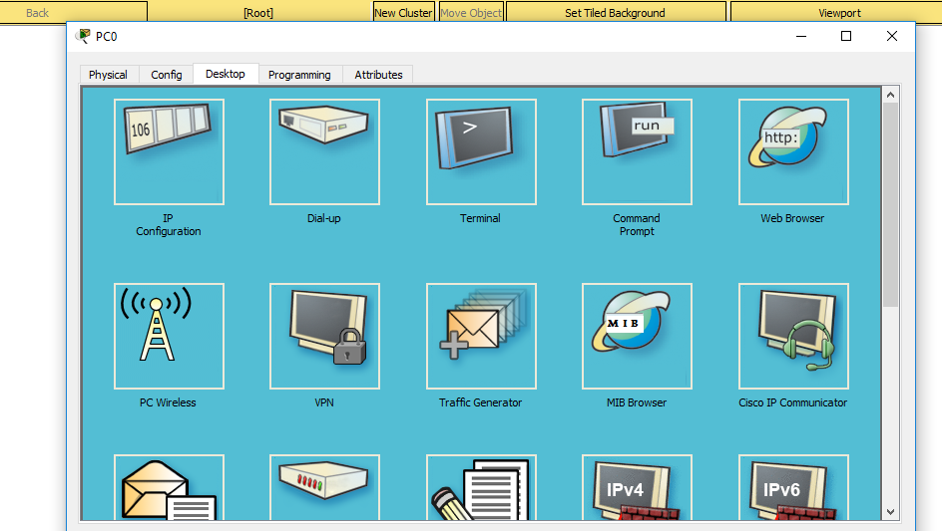

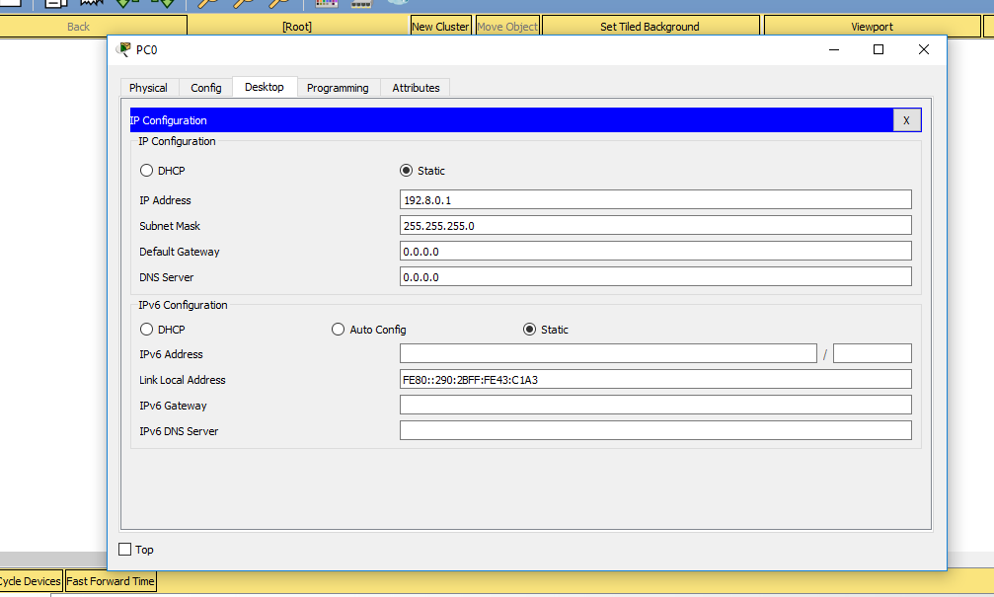

1. Connect all the devices with appropriate wire

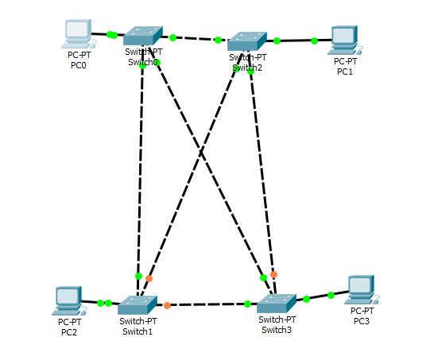

Step 5: Send the Message from Right hand side bar and check if you have succesfull connection

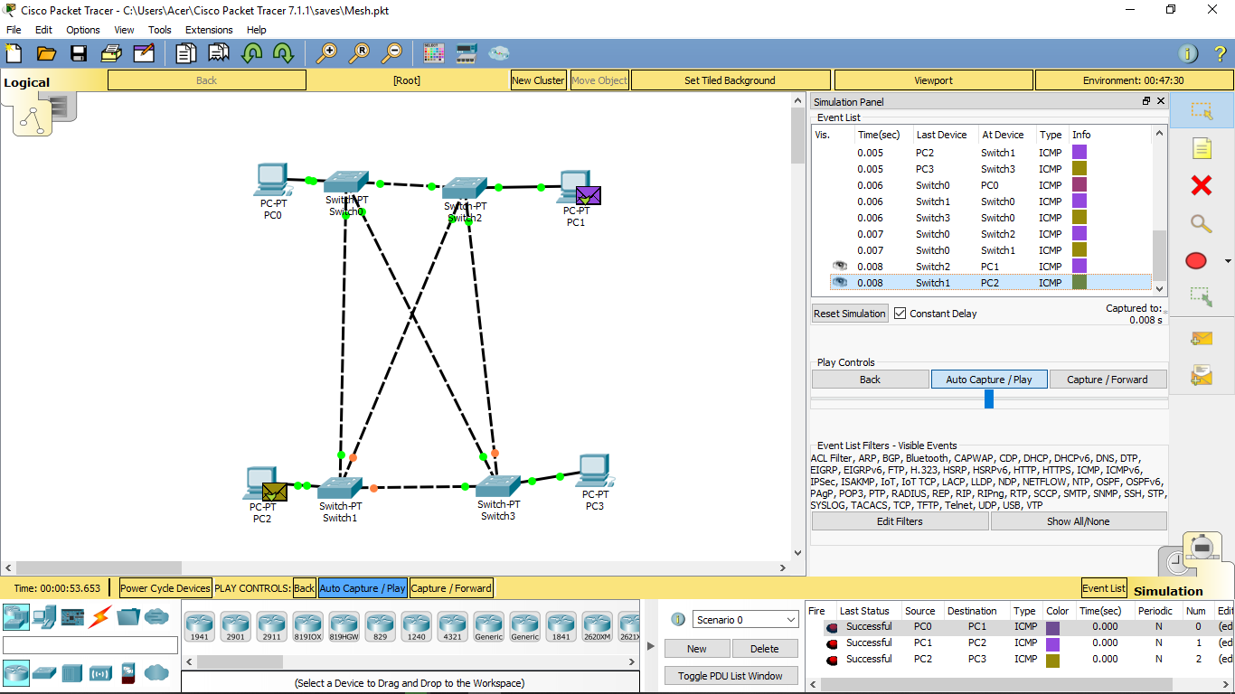

BUS TOPOLOGY

Alternatively referred to as a **line topology**, a **bus topology** is a network setup in which each computer and network device are connected to a single cable or [backbone](https://www.computerhope.com/jargon/b/backbone.htm). Depending on the type of [network card](https://www.computerhope.com/jargon/n/nic.htm) used in each computer of the bus topology, a [coaxial cable](https://www.computerhope.com/jargon/c/coaxialc.htm) or a [RJ-45](https://www.computerhope.com/jargon/r/rj45.htm) network cable is used to connect computers together.

**STEP:1**

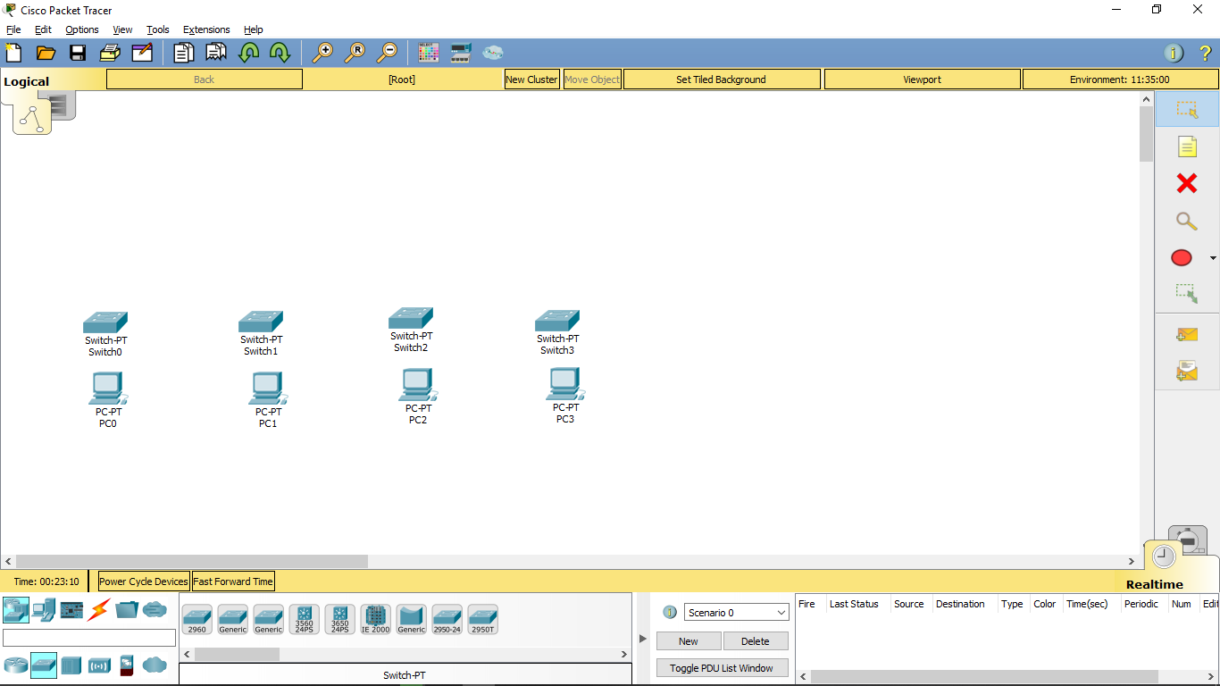

STEP:2

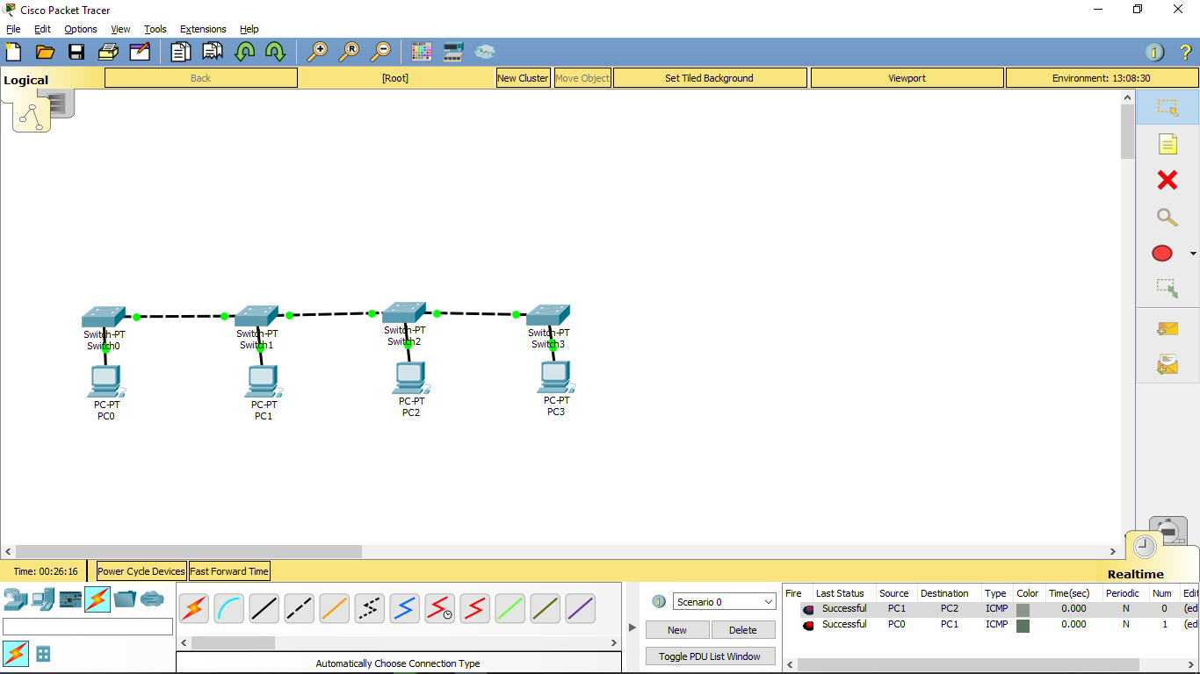

STEP 3:

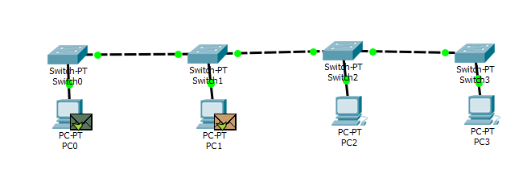

TREE TOPOLOGY

A **tree topology** is a special type of structure in which many connected elements are arranged like the branches of a tree. For example, tree topologies are frequently used to organize the computers in a corporate [network](https://www.computerhope.com/jargon/n/network.htm), or the information in a [database](https://www.computerhope.com/jargon/d/database.htm).

In a tree topology, there can be only one connection between any two connected nodes. Because any two nodes can have only one mutual connection, tree topologies form a natural [parent-child](https://www.computerhope.com/jargon/p/parechil.htm) hierarchy.

STEP 1: Connect Pc and Switches using cross wire and straight.

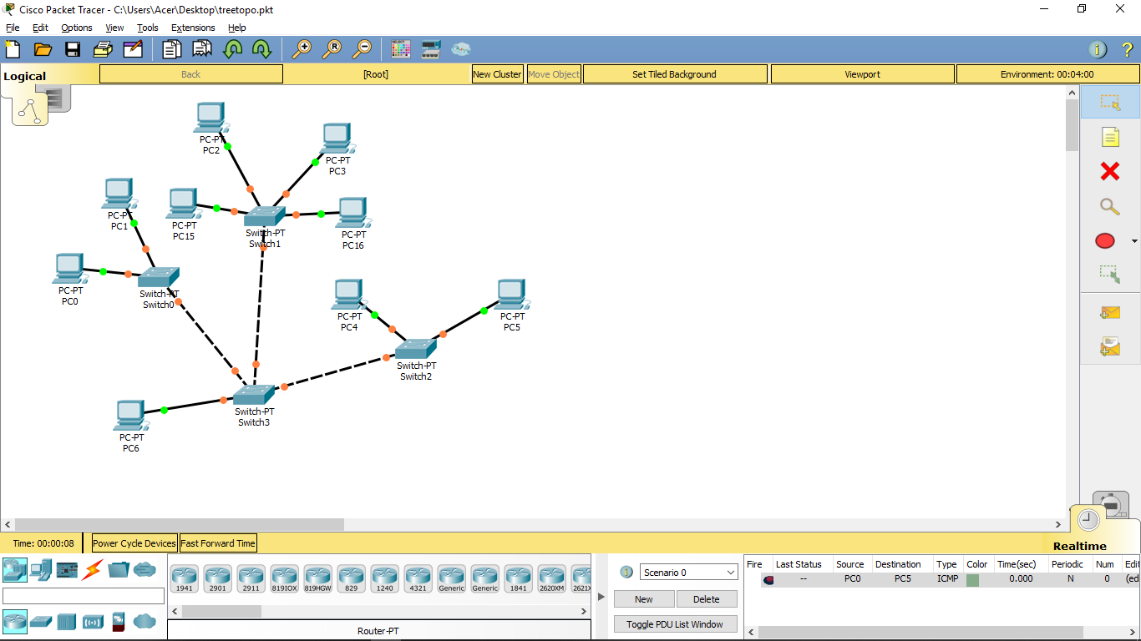

Step 2: Set Ip Address

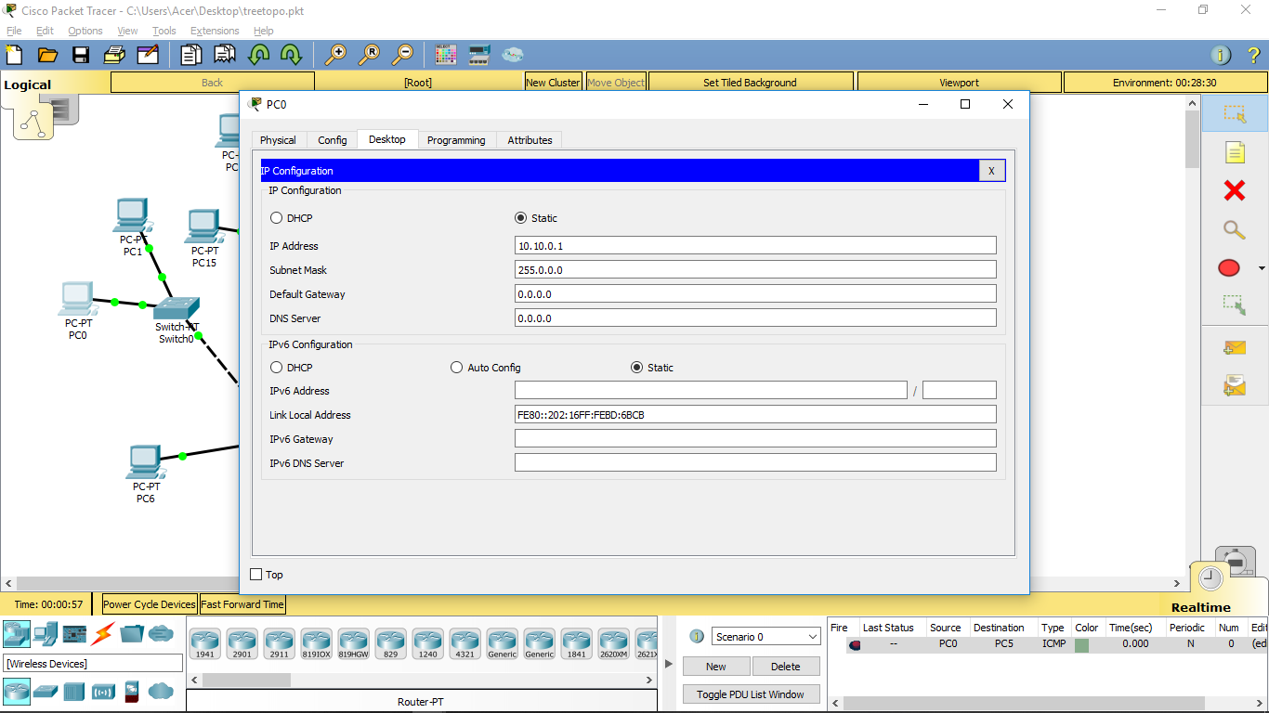

Step 3: Send the message and check the connection

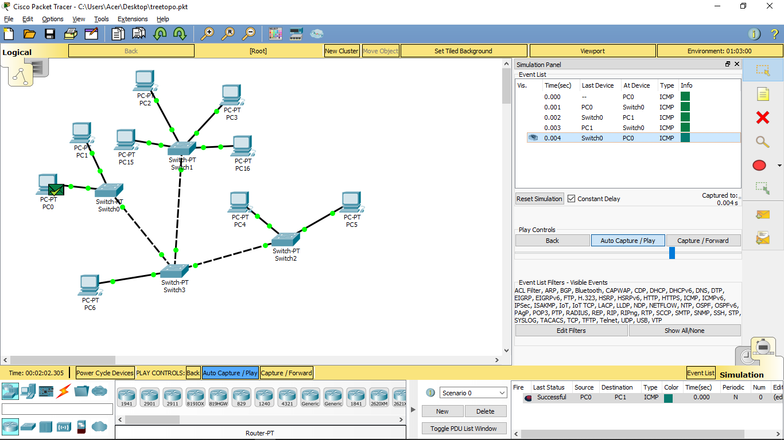

HYBRID TOPOLOGY:

A **hybrid topology** is a type of network topology that uses two or more differing network [topologies](https://www.computerhope.com/jargon/t/topology.htm). These topologies include a mix of [bus topology](https://www.computerhope.com/jargon/b/bustopol.htm), [mesh topology](https://www.computerhope.com/jargon/m/mesh.htm), [ring topology](https://www.computerhope.com/jargon/r/ringtopo.htm), [star topology](https://www.computerhope.com/jargon/s/startopo.htm), and [tree topology](https://www.computerhope.com/jargon/t/treetopo.htm).

Step 1:

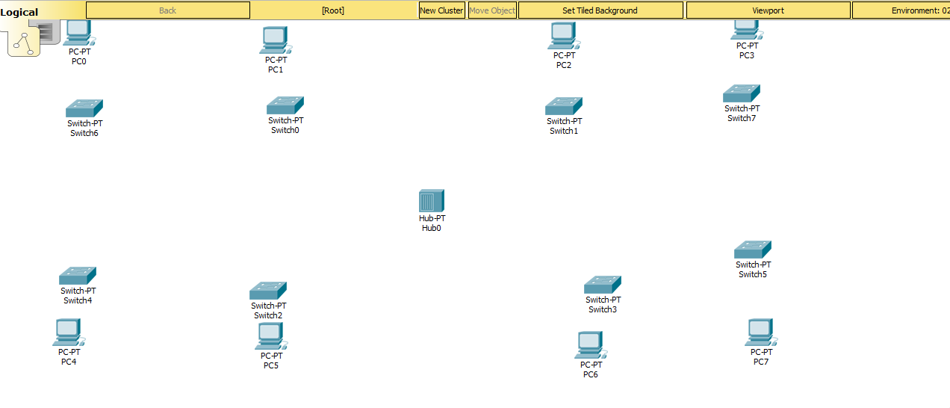

Step 2:

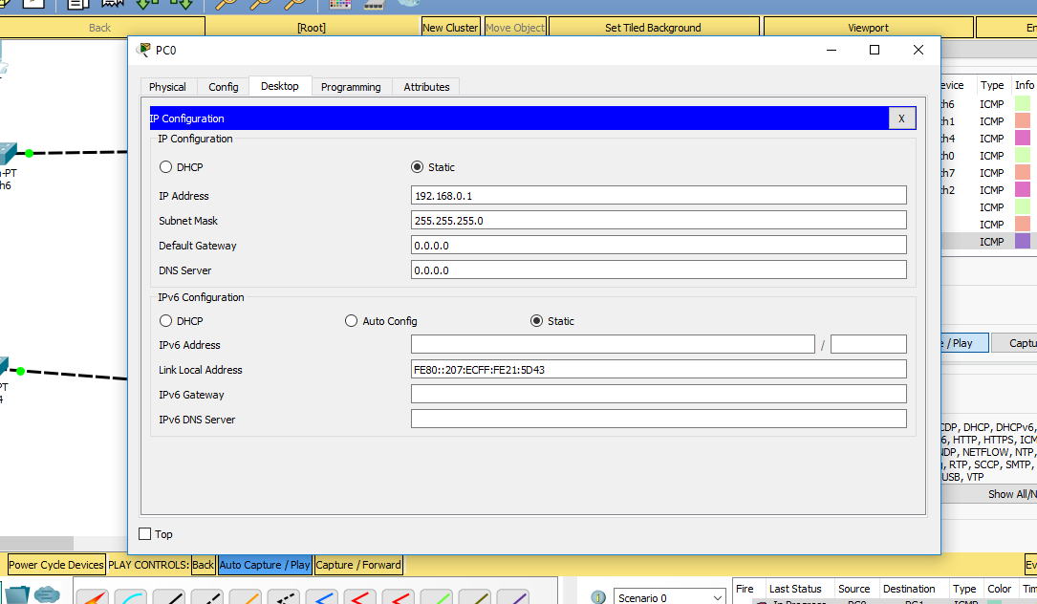

Step 3:

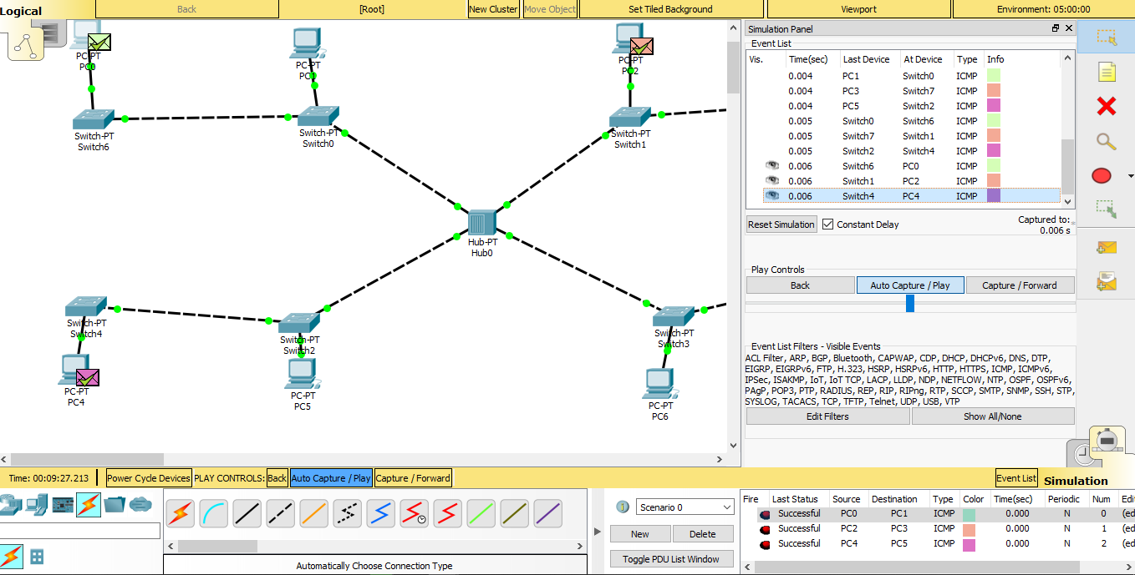

**RING TOPOLOGY:**

A **ring topology** is a [network](https://www.computerhope.com/jargon/n/network.htm) configuration in which device connections create a circular [data](https://www.computerhope.com/jargon/d/data.htm) path. Each networked device is connected to two others, like points on a circle. Together, devices in a ring topology are referred to as a **ring network**.

In a ring network, [packets](https://www.computerhope.com/jargon/p/packet.htm) of data travel from one device to the next until they reach their destination. Most ring topologies allow packets to travel only in one direction, called a **unidirectional** ring network. Others permit data to move in either direction, called **bidirectional**.

The major disadvantage of a ring topology is that if any individual connection in the ring is broken, the entire network is affected.

**Step 1:**

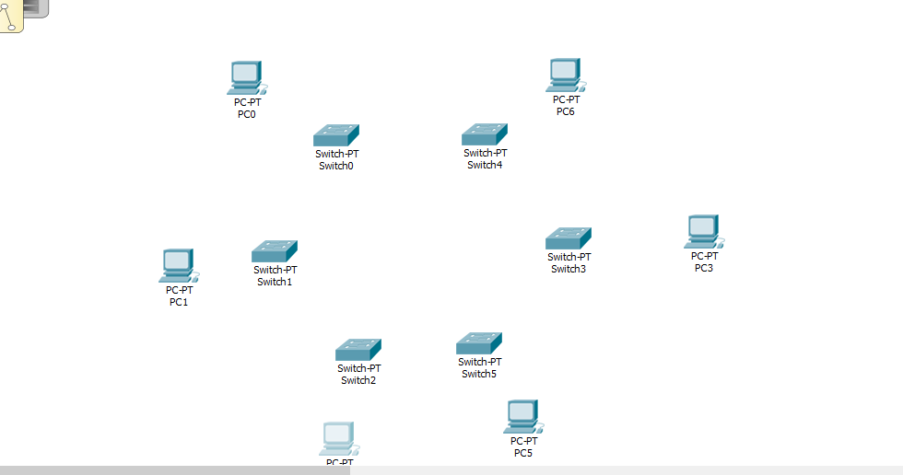

**Step 2:**

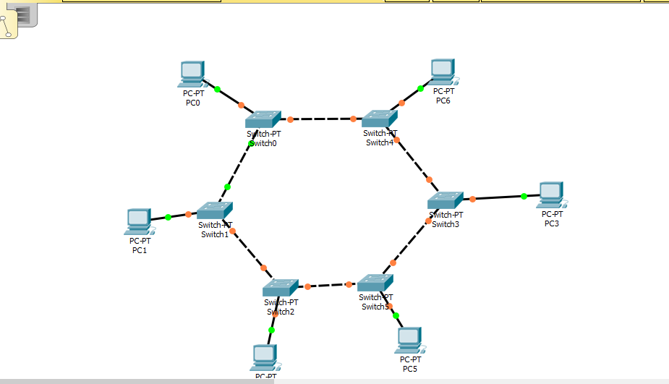

**Step 3:**

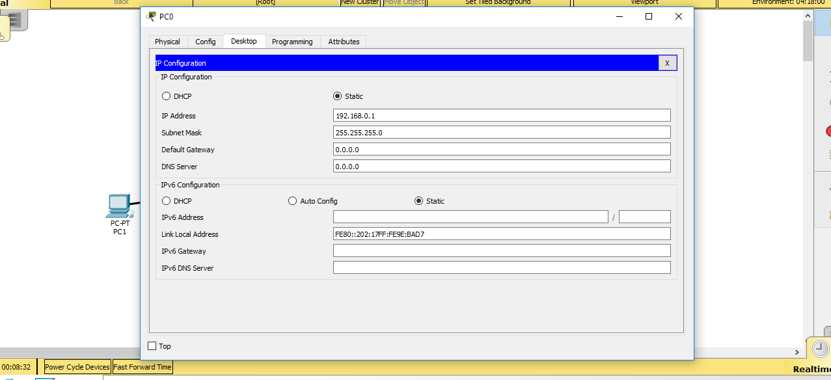

**Step 4:**

